### The root directory in Linux consists of various directories. / – Root

* Every single file and directory starts from the root directory.
* Only root user has write privilege under this directory.
* Please note that /root is root user’s home directory, which is not same as /.

The Linux file system(root folder) for currently logged in user is shown in the picture below.

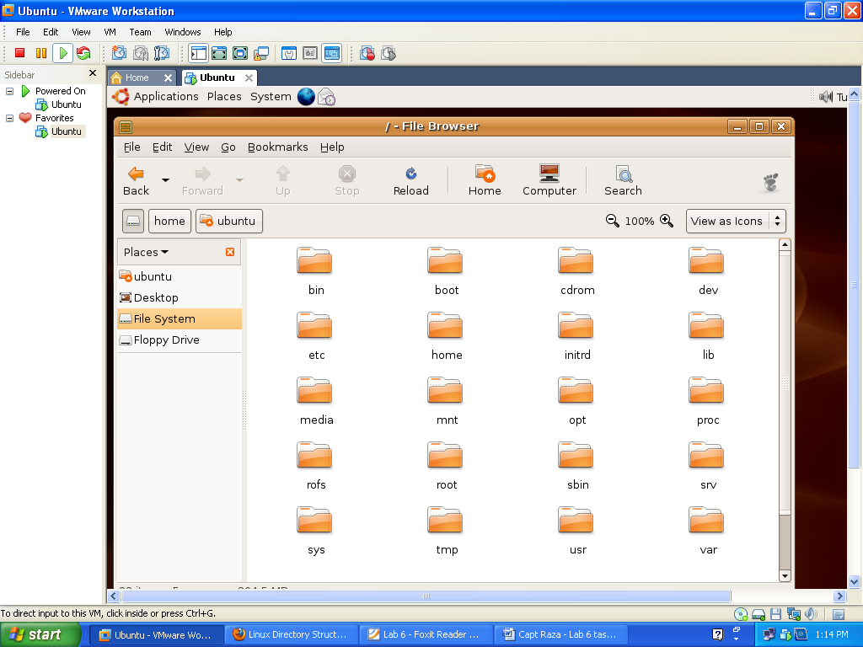

The basic functionality of each file system is shown in a tree as below.

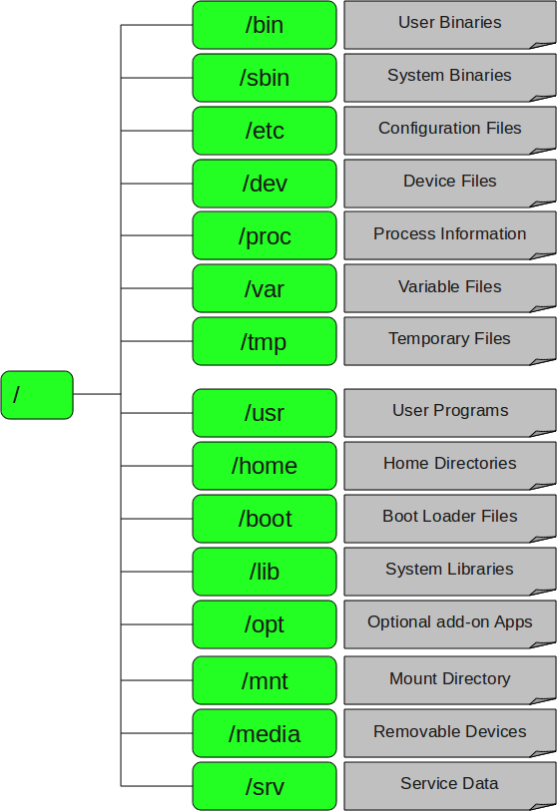

5 selected directories

**/sbin – System Binaries**

* This directory contains all the binaries that are essential to the working of the system. These include system administration as well as maintenance and hardware configuration programs. These are the essential programs that are required by all the users. Another directory that contains system binaries is /usr/sbin. This directory contains other binaries of use to the system administrator. This is where one finds the network daemons for system along with other binaries that only the system administrator has access to, but which are not required for system maintenance, repair etc.
* It is just like /bin, /sbin also contains binary executables.
* Example Commands: iptables, reboot, fdisk, ifconfig, swapon

**/dev – Device Files**

* This directory highlights one important characteristic of the Linux file system i.e everything is a file or a directory.
  + By looking through this directory, one should see hda1, hda2 etc, which represent the various partitions on the first master drive of the system.
  + /dev/cdrom and /dev/fd0 represent CDROM drive and floppy drive. This may seem strange but it will make sense if you compare the characteristics of files to that of your hardware. Both can be read from and written to.
  + Take /dev/dsp, for instance. This file represents speaker device. So any data written to this file will be re-directed to speaker.
  + Try 'cat /etc/lilo.conf > /dev/dsp' and one should hear some sound on the speaker. That's the sound of your lilo.conf file! Similarly, sending data to and reading from /dev/ttyS0 ( COM 1 ) will allow you to communicate with a device attached there.
* It also includes terminal devices, usb, or any device attached to the system.

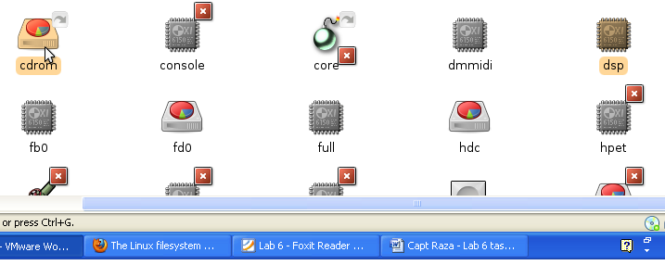

**/usr – User Programs**

* This is one of the most important directories in the system as it contains all the user binaries. User binaries and its supporting libraries can be found here. User programs like telnet, ftp etc are also placed in it.
* Contains binaries, libraries, documentation, and source-code for user programs.
* /usr/bin contains binary files for user programs.
* /usr/sbin contains binary files for system administrators.
* /usr/include contains 'header files', needed for compiling user space source code.
* /usr/lib contains libraries for /usr/bin and /usr/sbin
* /usr/local contains users programs that you install from source.
* /usr/share This directory contains 'shareable', architecture-independent files

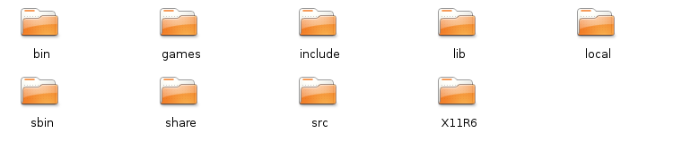

**/mnt – Mount Directory**

* This is a generic mount point under which user mount file systems or devices. Mounting is the process by which user makes a file system available to the system. After mounting, files will be accessible under the mount-point. This directory usually contains mount points or sub-directories where user mounts floppy and CD. User can also create additional mount-points here if he/she wants. There is no limitation to creating a mount-point anywhere on the system but convention says that user do not litter file system with mount-points.
* The mounting can be done by
  + $ **mount /dev/hda2 /home**
* To specify File system type, use –t in the command
  + **mount -t msdos /dev/fd0 /floppy**

**/srv – Service Data**

* It contains site-specific data which is served by this system. This main purpose of specifying this is so that users may find the location of the data files for particular service, and so that services which require a single tree for read only data, writable data and scripts (such as cgi scripts) can be reasonably placed. Data that is only of interest to a specific user should go in that users' home directory.
* srv stands for service. Contains server specific services related data.